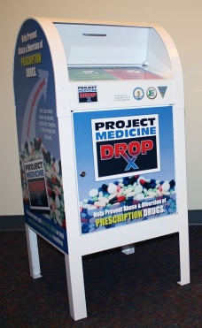
NEWS RELEASE

April 25, 2012

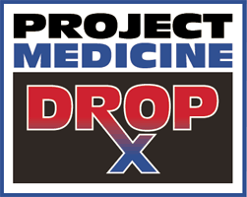
Sheriff Frank J. Provenzano
Somerset County Sheriff’s Office 908.231.7143 provenzano@co.somerset.nj.us

SOMERSET COUNTY ANNOUNCES
YEAR-ROUND MEDICINE DROP-OFF SITE
Collection program addresses growing problem of prescription drug abuse
& concerns about improperly discarded medicines harming the environment
SOMERVILLE – Somerset County has begun a free medicine-collection program for residents to safely dispose of unwanted, expired or unused medicines. This is the first year-round medicine collection offered in the Somerset County area.
The drop-off site set up by the New Jersey Division of Consumer Affairs, in cooperation with the Somerset County Sheriff’s Office and the Somerset County Board of Freeholders, accepts prescription and over-the-counter drugs, as well as pet medicines.
Medicines from households are accepted Monday through Friday, 8:30 a.m. to 4:30 p.m., at the entrance of the Sheriff’s Office, located at the lower level of the county administration building. To search for directions online or via GPS device, use this address: Somerset County Administration Building, 20 Grove St., Somerville, NJ 08876.
For drop-offs after hours and on holidays and weekends, residents are asked to go to the secured front entrance of the Somerset County Administration Building on Grove Street, dial 908-526-2500 on their cell phone, and request a Sheriff’s cadet escort. A Sheriff’s cadet will greet them at the door and escort them to the medication drop box.
“The drop-off program is a free, anonymous, no-questions-asked initiative that prevents pill abuse and theft by ridding homes of potentially dangerous expired, unused and unwanted prescription drugs,” said Sheriff Frank Provenzano. “Medicines that languish in home cabinets are highly susceptible to diversion, misuse and abuse.”
-more-

Project Medicine Drop – page 2 of 2

“Unused medicine left in the home poses health and safety threats, and improperly disposed- of medicines can end up in our water system and streams, and harm wildlife,” said Somerset County Freeholder Director Patricia Walsh. “This year-round collection program helps prevent crime and protects the environment.” She noted that the Somerset County program is being launched during National County Government Month, the theme for which is “Healthy Counties, Healthy Families.”
Any questions please contact:

Somerset County Sheriff’s Office
20 Grove Street
Somerville, New Jersey 08876
908-231-7140 X-9
www.somcosheriff.org
More than seven million Americans currently abuse prescription drugs, according to a 2009 national survey on drug use and health. Nationally, every day approximately 2,500 teens use prescription drugs to get high for the first time, according to the Partnership for a Drug Free America.
“Most teens who abuse prescription drugs get them from family and friends, including the home medicine cabinet,” said Sheriff Provenzano. “Painkillers, depressants, stimulants, and over-the-counter cough medicines are the medicines most often abused. These are the most important drugs to remove from your home if they are unwanted, expired or unused.”
Medicines from households are accepted in any form, including prescriptions, over-the-counter and pet medicines. Individuals are asked to keep medicines in their original container, use a marker to cross out their name if they wish, and then place the medicines in a clear plastic bag. Medicine that is no longer in its original container should be placed in a clear plastic bag with the name of the medicine written on the bag.
The drop-off site is for individuals only; no medicines will be accepted from businesses, healthcare facilities, pharmacies, doctors’ offices or veterinary clinics. The drop box cannot accept syringes.
For more information or questions about items accepted, call the Sheriff’s Office at 908-231-7140, ext. 9. Visit the Project Medicine Drop website at www.nj.gov/oag/ca/meddrop for the best ways to dispose of unused medications and to keep medications safe within the home.
# # #

